1.The following screenshot shows the factorial of a number

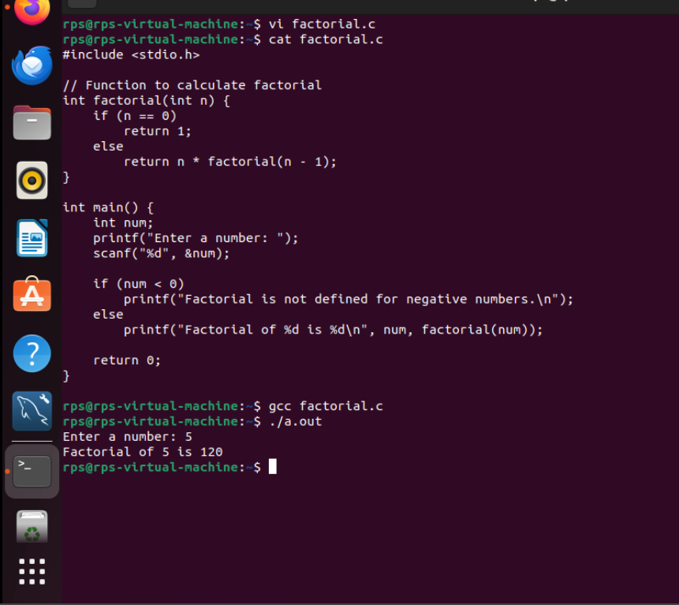

2.The following screenshot shows fibonacci series

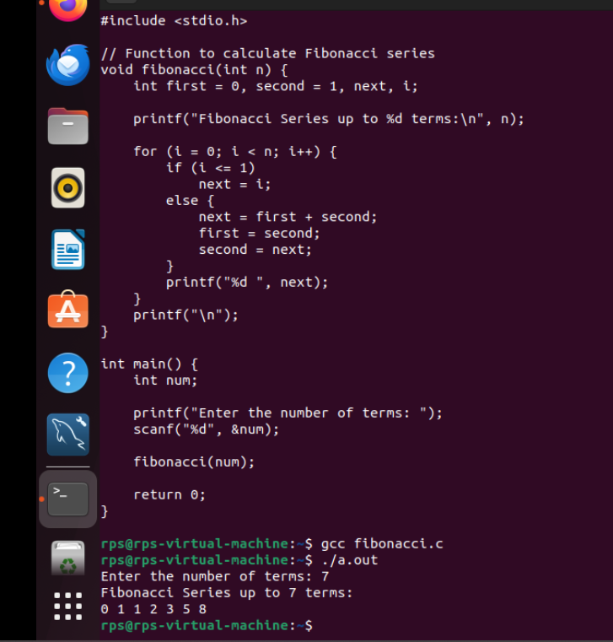

3.The following screenshot prints stars using for loop:

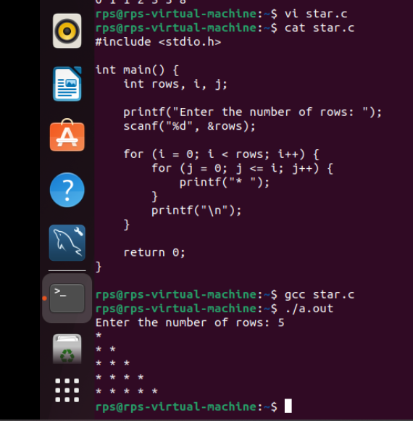

4.the following screenshot shows the matrix multiplication

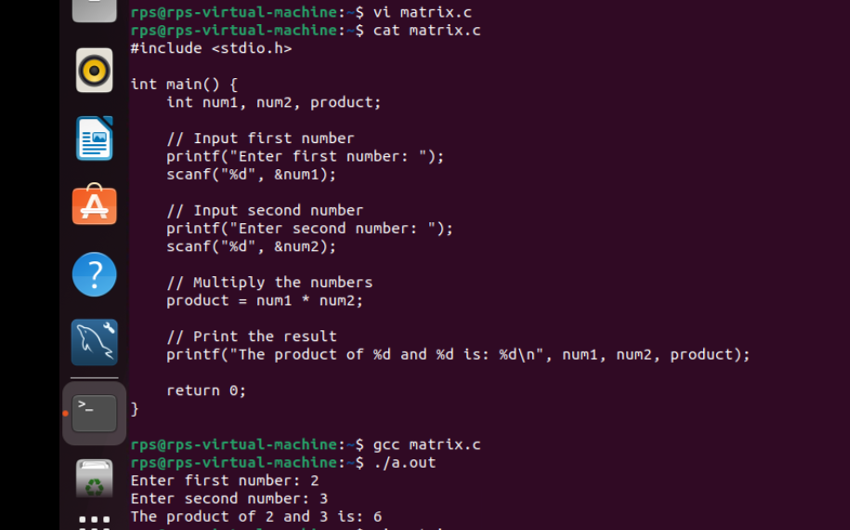

5.the following screenshot shows the elements of the array

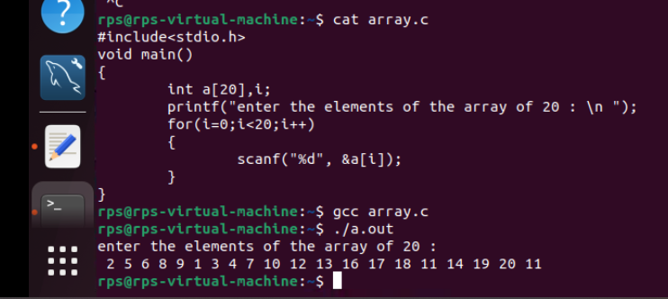

6.the following screenshot shows the array of elements with index value

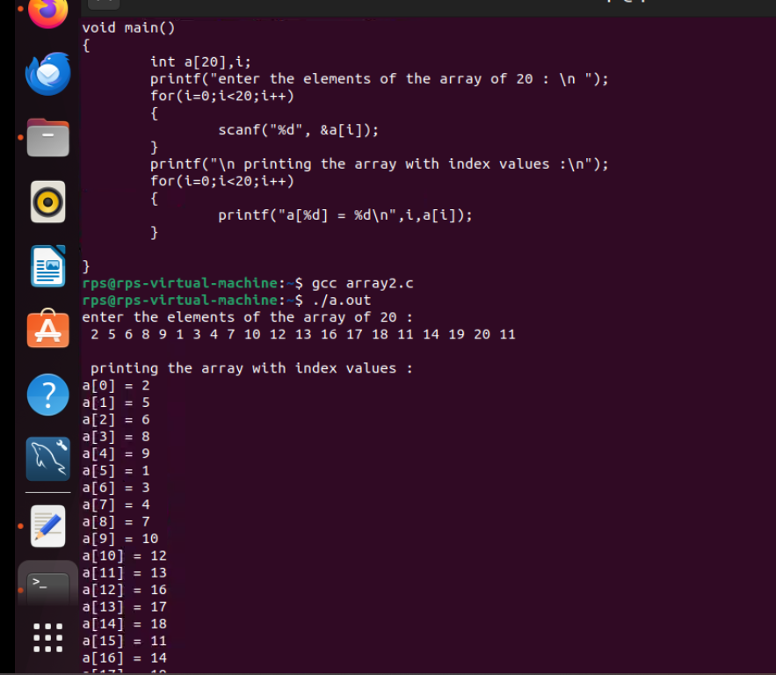

7.the following screenshot shows the index value which is to be deleted

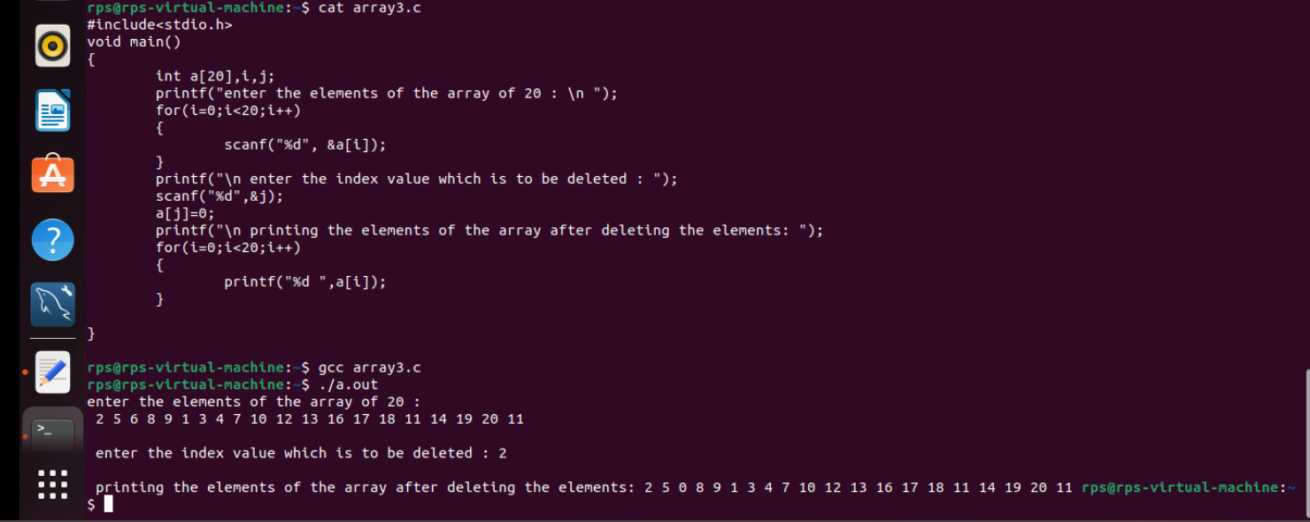

8.the following screenshot shows duplicate elements

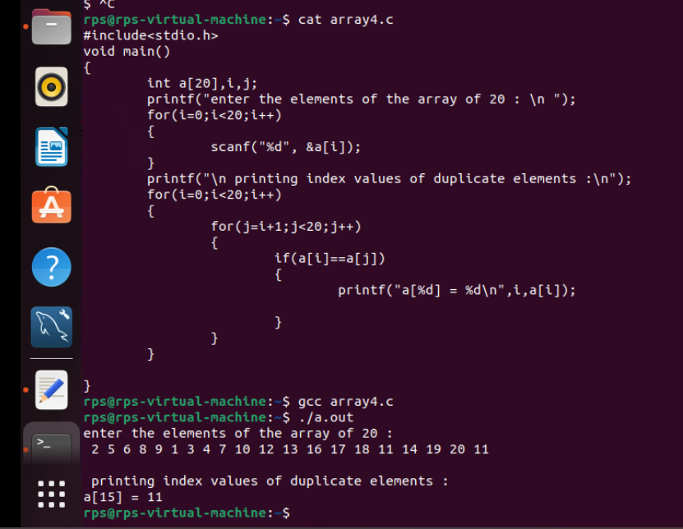

9.the following screenshot shows the element which is to be searched

